FOR IMMEDIATE RELEASE
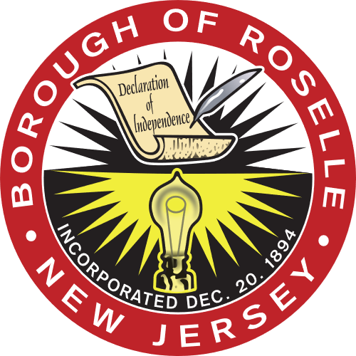

Roselle Mayor and Borough Council Honors Mama’s Gourmet Pizza Owner

Theresa Candido, Affectionately Known as “Mama,” Retiring After 39 Years

ROSELLE, NJ - Theresa Candido has been hand-crafting delicious pizza, calzones and pasta dishes for almost 40 years at her pizza shop on Raritan Road.

Candido was honored for being a staple in the community, both as a business owner and a resident, at the regular Borough Council Meeting on Jan. 19.

“Today, we celebrate her retirement and as owner of Mama’s Gourmet Pizza, Ms. Candido has serviced the Borough in good standing for the past 39 years,” said Fifth Ward Councilman John Fortuna, who read the proclamation to Candido and her family.

Born in Calabria, Italy, Candido relocated to Brooklyn in 1975. She opened a pizzeria in Roselle in 1982; it became Mama’s Gourmet Pizza in 1998. After finding a strong community within the Borough, she then decided to move to town.

“It was important to honor Mama because she made her dreams possible right here in Roselle. She not only built a family but a business in this Borough and then dedicated her life to being a part of the community for decades,” said Mayor Donald Shaw. “Her delicious, authentic pizza and her service with a smile will surely be missed.”

Mayor Shaw reflected on how Candido was always an important sponsor of Borough events, especially those that involved children.

“Thank you so much and I will miss everyone,” Candido said to the Borough Council.

Candido is a resident of the Fourth Ward where she is the proud mother to three children, Maria, Silvana and Joseph, and grandmother to Giovanni and Giuliana. She is eagerly awaiting her third grandchild in June.

Fortuna, the councilmember who orchestrated the proclamation, said that honoring Candido was the “highlight of the night.”

“We have lost the legend, so to speak, and walking into the pizza shop will not be the same without Mama. We wish her all the best,” he said.

End.

